[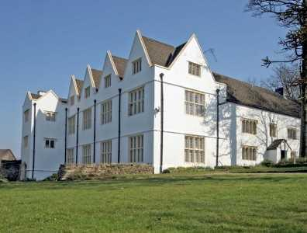](http://www.google.co.uk/url?sa=i&rct=j&q=&esrc=s&frm=1&source=images&cd=&cad=rja&uact=8&ved=0ahUKEwih6uH55OzSAhWkIMAKHQjACGMQjRwIBw&url=http://www.rightmove.co.uk/property-for-sale/property-21672066.html&psig=AFQjCNGzvIcB2JUNFYQ8JoIy3sKZ7-TJow&ust=1490364043607526)

Van Mansion, Caerphilly

Have you ever dreamed of living in a Tudor Mansion?

Cwrt Rawlin Estate Agents are delighted to present to you a magnificent Tudor house;

It is a stunning place. There are grand staircases and many awesome rooms! It has 10 wonderful rooms for adults and children to enjoy.

With incredible gardens, bright green grass and beautiful flowers it really shines bright over looking Caerphilly with superb views.



Come and see this glamorous house. It looks amazing and you won’t be disappointed!

The house is exquisite! You will be amazed!

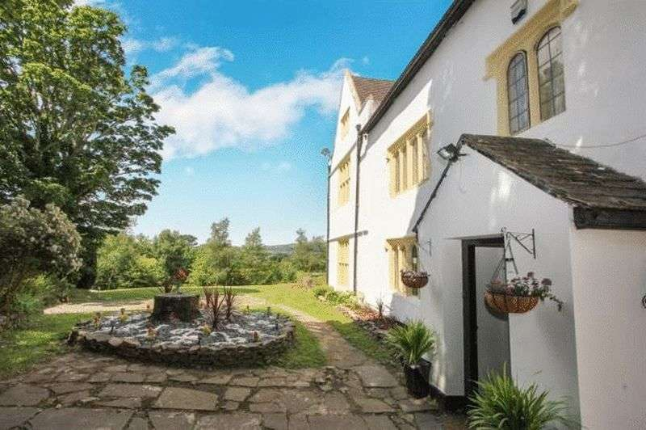

Not only do you get a house but you also get a dovecote. It’s the biggest in Europe ! 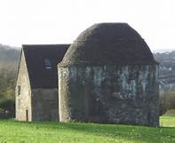

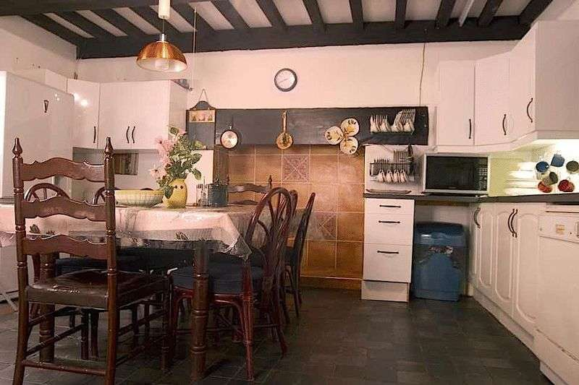This is the kitchen. It has Tudor beams and a Tudor fire place. With a stone floor and plenty of room it is ideal for a big family.

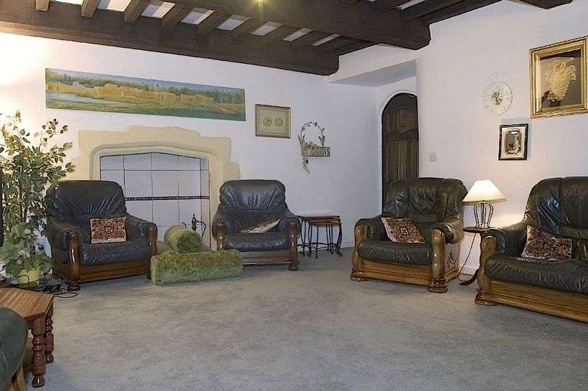This is one of the spacious family rooms which also has Tudor features for you to enjoy. It can be used for many glamorous occasions.

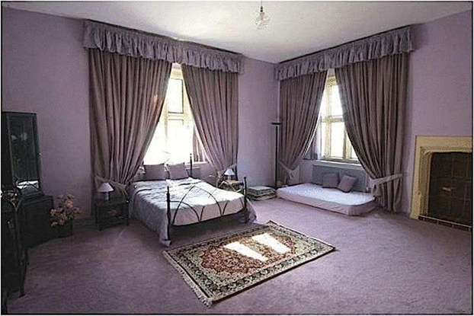This is one of the many fabulous bedrooms with lots of bright windows that brighten up the room and it show’s wonderful views of Caerphilly.

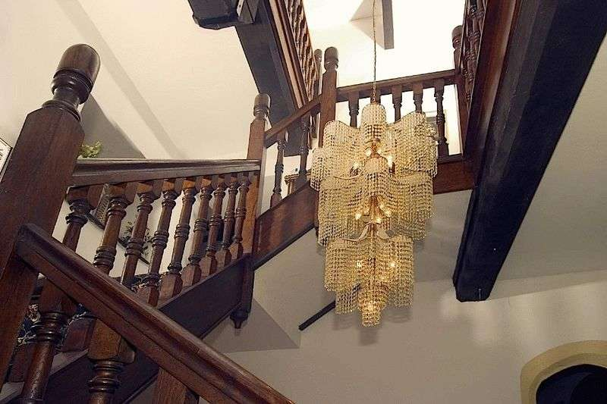  
These are the Grand staircases they are so beautiful that you could look at them all day! There is so many of them.

It only costs £799,995.

Ring Cwrt Rawlin Estate Agents now on

02920807070

By Seren marks, Eryn Davies and Phoebe Arnold